

**Reflections on my first four votes on the MPC**

Speech given by

Professor David Blanchflower, Member of the Monetary Policy Committee, Bank of England

27 September 2006

I am grateful to Lavan Mahadeva, Jumana Saleheen, Chris Shadforth and Nicola Dufty for their help in preparing this speech. I would also like to thank Kate Barker, Charlie Bean, Martin Brooke, Andrew Holder, and Andrew Wardlow for their helpful comments.

1

All speeches are available online at [www.bankofengland.co.uk/publications/Pages/speeches/default.aspx](http://www.bankofengland.co.uk/publications/Pages/speeches/default.aspx)

1. I am particularly pleased to be in Wales for my first speech. The family on my mother’s side came from Swansea. I have happy childhood memories of summers spent on the Gower coast particularly swimming in the cold sea at Oxwich, Caswell and Horton. My parents lived here for forty years until they moved a month ago, much to my surprise as I had planned on staying with them tonight! I went to school in Cardiff at what was then Canton High School for Boys, now Cantonian High School, and had an inspiring teacher, John Kitchker, who first introduced me to the joys of economics at A- level. I returned to University College, Cardiff for my Masters degree in Economics some years later and even taught some classes at the Export Credit Guarantees Department across the road from the Economics Department. I also recall with pleasure several years as a junior member of Wenvoe Castle Golf Club where I first became addicted to golf. I am now a member of Royal Dornoch Golf Club in the north – Scotland to be precise! Anyway, I have many happy memories of south Wales and am pleased to be here today.
2. I have now been a member of the Monetary Policy Committee (MPC) for nearly four months and voted four times. In the first two votes in June and July of 2006, I went along with the majority of other Committee members in voting for no change. But in August I was the sole dissenting vote in what the governor of the Bank, Mervyn King, described at the August *Inflation Report* press conference as a ‘knife-edge vote’. I believe that is an appropriate characterisation: the vote for me was a very close-cut call, and principally came down to differences in views on the level of spare capacity in the economy. In this speech I aim to set out how I came to make my August decision, and my subsequent view of the economy.
3. The remit of the MPC is to control inflation – hitting the inflation target is our primary purpose. Subject to this goal, the Committee is also responsible for supporting “the economic policy of Her Majesty’s Government, including its objectives for growth and stability”.
4. The inflation target of 2% is expressed in terms of an annual rate of inflation based on the Consumer Prices Index (CPI). The remit is not to achieve the lowest possible inflation rate. Inflation below the target of 2% is judged to be just as bad as inflation above the target. The inflation target is therefore symmetrical. Furthermore, a target of 2% does not mean that inflation will be held at this rate constantly. The MPC’s

aim is to set interest rates so that inflation can be brought back to target within a reasonable time period, without creating undue instability in the economy.

1. In order to achieve this goal, the MPC, along with the Bank’s Staff, spends a lot of time analysing and interpreting data. So, the big question is what was there in the data back in August that made the MPC move from a unanimous vote for no change in July to a six to one vote for an increase? The answer is principally two-fold, reflecting concerns about the medium term profile for inflation and the degree of spare capacity in the economy. I intend to talk about both these issues, starting with spare capacity.
2. Policymakers often gauge the extent of inflationary pressures in the economy by looking at the balance between the level of demand in the economy against the supply potential of the economy – the output gap, or the degree of spare capacity in the economy. The output gap is related to the unemployment gap, the difference between the natural rate of unemployment and the rate of unemployment itself. When unemployment is at its natural rate, there is neither upward nor downward pressure on inflation. Let’s take an example where unemployment is at its natural rate, but firms put extra pressure on their workers to work longer hours or be more productive. These firms may have to compensate workers for their extra hours and effort. This is an example of reduced spare capacity *within* firms, which can lead to inflationary pressures. So, one can think of the output gap as being the sum of two parts, the degree of spare capacity in the labour market (or the unemployment gap) and the degree of spare capacity *within* firms. I will use this simple framework to argue that I did not feel that there was any news in the data in August that convinced me that there was less spare capacity in the UK economy relative to July, in contrast to some of my colleagues.
3. Each Summer, the Office for National Statistics (ONS) publishes revisions to its past estimations of national output, expenditure and income to reflect the receipt of less timely data. These latest estimates of annual economic growth show that the economy grew more strongly in 2003 and 2004 than estimated at the time of the May *Inflation Report* (Chart 1). The new data also imply that the slowdown in 2004-2005 was more pronounced than previously reported, but that the recovery since then has been correspondingly stronger, although these data are subject to revision themselves. The revised level of output over the recent past could indicate that the economy is operating with less spare capacity than previously thought. Some external support for this view is

provided by the upward revisions to both the OEF and NIESR output gaps between April and July (Chart 2).

1. A reduction in the output gap would be consistent with some tightening in the labour market or a decrease in the degree of spare capacity within firms – how hard firms work labour and capital. It could also be some combination of the two. So, what did these data say back in August?

**Wage pressures and spare capacity in the labour market**

1. Turning first to the labour market, the unemployment rate had been trended up for some time (Chart 3) – which is evidence of loosening rather than tightening. At the time of my August decision the unemployment rate was 5.4% for the month of May, up from a low of 4.7% in August 2005. I note also that the unemployment rate in Wales, which was below that of England in 2005Q1 (4.6% and 4.7% respectively) was above it in 2006Q2 (5.7% and 5.5%).1
2. The claimant count had increased less dramatically, in part reflecting higher unemployment among more vulnerable workers who may not be entitled to unemployment benefits, for example younger workers, low skilled workers and immigrants. This, together with some evidence of increasing durations of unemployment tended to suggest that the rise in unemployment was primarily cyclical in nature, rather than structural. The reason why I believe it is cyclical is that one would expect the vulnerable groups in the labour market to be hit first by weaker labour demand. And we know that the average duration of unemployment is higher in periods of softer labour demand growth. But when forming my judgment about how the economy might evolve going forward it was important to understand why this change had occurred.
3. The degree of tightness in the labour market can be driven by factors affecting demand and/or supply. One explanation for the recent increase in unemployment might be the upward trend in oil prices over the past two years. An increase in the price of oil may lead firms to seek to rein in other costs, such as labour, or at least reduce their

1 Source: StatWales. However, the Welsh outturn for 2006 Q2 looks somewhat volatile having been 4.7% in 2006Q1.

expectations of future recruitment. Chart 4 shows that since 1971, there have been five episodes during which the oil price has risen significantly (detailed in Chart 5).2 It shows that during the first three episodes, the oil price hike was followed by a recession: a sharp rise in the unemployment rate. But following episode IV, the unemployment rate was largely unaffected.

1. One could argue that the first three episodes were different because the oil price hikes were the result of disruptions in oil supply, whereas in episode IV and the current episode the oil price hike is more likely to be related to increased global demand. In that case, the observed rise in unemployment might remain modest going forward, or even fall, as it did during episode IV. But of course, there is always a risk that episode IV is the outlier; alerting us to the possibility that unemployment might rise more sharply should the demand for labour fall.
2. Consistent with muted labour demand, recruitment difficulties reported by contacts of the Bank’s Agents were down ahead of my August decision, while the Recruitment and Employment Confederation survey data (REC) showed that the demand for permanent staff was around its long run average (Chart 6). The recruitment rate – defined as the proportion of individuals with tenure of less than three months - continued its steady decline (Chart 7). The survey measures of employers’ future employment intentions, reported by the Agents and the British Chambers of Commerce had recently fallen (Chart 8). The number of vacancies had also risen.
3. The story was a little different at a disaggregated level. KPMG data suggested that staff availability was more of a limiting factor to recruitment in the financial and professional service industries.3 This fitted with what the Bank’s Agents were being told about employment intentions in the Financial and Business services sectors. So it seemed that different sectors of the economy were probably experiencing different conditions at the time. But in my view, in aggregate, there seemed a high

2 See Walton, D. (2006), “Has oil lost the capacity to shock?”, Bank of England Quarterly Bulletin, Spring, 46(1), pp. 105-114.. For the US, see Carruth, A.A., M.A. Hooker and A.J. Oswald (1998), “Unemployment Equilibria and Input Prices: Theory and Evidence from the United States,” Review of Economics and Statistics, Vol. 80(4), pp. 621-628.

3 REC/KPMG LLP (2006) “Report on Jobs”, August.

likelihood that unemployment had increased in part as a result of more muted labour demand.

1. However, part of the explanation for the rise in unemployment is also that labour supply has increased, especially among older age groups, perhaps in part because of declining incomes from defined contribution plans.4 Economic theory tells us that the expected wage of workers is higher during booms than in recessions, encouraging a larger fraction of the workforce to participate during a boom.5 For this reason one would normally expect an increase in the unemployment rate to be followed by a fall in the participation rate. But recently there has been a continued rise both in participation and employment, in spite of the rise in unemployment. Chart 9 shows the unemployment, employment and participation rates for the UK since 1971 and how the three rates have evolved over the economic cycle, and importantly for the current conjuncture, how they have moved following the most recent rise in unemployment. To aid this, marked on the chart are vertical lines showing the past troughs in the unemployment rate. It shows that in the past, the employment and unemployment rates are mirror images of one another: following a rise in the unemployment rate the participation (activity) rate was flat in 1973, rising a little and then falling in 1979 and falling sharply in 1990. My assumption is that the participation and employment rates will start to turn down if unemployment continues to rise, as has happened in previous episodes.
2. The continued rise in participation at present may in part reflect increasing migration to the UK; an increase in labour supply (Chart 10). There has been a notable increase in the inflow of migrants since the accession of the A8 countries (Czech Republic; Estonia; Hungary; Latvia; Lithuania; Poland; Slovakia and Slovenia) on May 1st 2004. Preliminary research6 shows that immigrants born in the A8 countries made up only around 0.6% of the stock of foreign born individuals in the UK in 2005. But their

4 The economic activity rate of those aged 16 and over increased from 63.0% in April-June 2004 to 63.6% in April-June 2006. The rates by age for the two years respectively were as follows: age 16-17 - 52.0% and 47.1%; age 18-24 74.7% and 74.5%; age 25-34 – 83.6% and 84.7%: age 35-49 – 84.7% and 85.3%: age 50-

59 (women) – 68.4% and 70.2%: age 50-64 (men) – 74.5% and 75.1%: age 60+ (women) – 10.1% and

11.4%: age 65+ (men) – 8.8% and 10.0%. Source: First Release, Labour Market Statistics, August 2006,

ONS, Table 12(1).

5 See Clark, K.B and L.H.Summers (1982), “Labor force participation: timing and persistence”, Review of Economic Studies, Vol. 49, (1982), pp. 825-844.

6 I am grateful to Jumana Saleheen and Chris Shadforth for allowing me to draw on some of their work.

share in terms of the immigrants who have arrived in the past two years is much bigger, now accounting for around 1 in 4 of new arrivals. This research also shows that, on average, immigrants who arrived in the UK in the past two years were somewhat less likely to be employed than the indigenous population. But within that group of immigrants there are differences. Those born in the A8 countries had higher employment rates compared to those born elsewhere. So, immigrants may have swelled the participation, employment and unemployment figures.

1. Pay pressures appear to have been constrained by the recent increases in labour supply, especially from increased immigration from Eastern Europe and rising participation of older workers and rising unemployment.7 Whole economy twelve-month Average Earnings Index (AEI) weighted settlements had been easing continuously since July 2005 at the time of my August decision (Chart 11). And regular pay growth had been flat or slowing on most measures since late 2004 (Chart 12 and Table 1). Moreover, the wage of new immigrants (including those from the A8 countries) has been strikingly weaker in the recent past (Chart 13)6, and some of this weakness is likely to have helped to moderate wage pressures in some sectors. The National Institute in their July Economic Review noted that employers are likely keeping down pay raises as many firms are contributing large amounts of money to their pension funds. These payments, the NIESR estimate, together with higher national insurance contributions have increased from 13 per cent of total labour costs in 2001 to around 17 per cent in the first quarter of 2006.8
2. A particular problem with wage data based on sample surveys, such as the AEI, is that they exclude data from workers at the low-end of the wage distribution. For example, the ONS calculates the AEI using survey data from firms that employ more than 19 people. Hence, the wages of workers employed in smaller firms, which are frequently non-union, and have lower and more flexible wages than those of bigger,

7 The wage curve shows that the level of real wages is related to the level of unemployment – a doubling of unemployment reduces real wages by about ten percent. See Blanchflower, D.G. and A.J. Oswald (1994a), The Wage Curve, MIT Press, Cambridge, Massachusetts; Blanchflower, D.G. and A.J. Oswald (2005), “The wage curve reloaded”, NBER Working Paper #11338. Brian Bell; Stephen Nickell and Glenda Quintini (2002), “Wage equations, wage curves and all that”, Labour Economics, July, 9(3), pp. 341-360.

8 Barrell, B., Kirby, S., and Riley, R. (2006), “UK economy forecast,” National Institute Economic Review, No. 197.

unionised workplaces, are excluded.9 In addition, the 3.72 million self-employed are also excluded from the AEI wage series.10 Their earnings are also likely to be flexible downwards in periods of rising unemployment and reduced work opportunities. 11 Based on current estimates from the Labour Force Survey these two sample exclusions account for some 29% of workers, or over 8 million workers. Hence, the AEI and other similar measures tend to *overestimate* wage growth in the economy when there is slack in the labour market.12 This makes it more difficult to assess the current level of wage pressure. At present, I see *no* evidence of any second-round wage effects from the recent oil price increases

1. I also believe we will see a decline in the employment rate and further rise in unemployment going forward because of the current composition of employment growth. Of the 1.5 million new jobs created since 2000Q1, 38.1% were public sector employees, 30.3% were self-employed workers with the remaining 31.6% of the new jobs among private sector employees. In 2006Q1, out of 28.9 million workers, 13.0% were self- employed, 20.3% were public sector workers and 66.8% private sector employees.13 This compares with 12.0% self-employed, 19.3% public sector employees and 68.7% private sector employees in 2000Q1. It seems unlikely that there will be similar growth in employment in the future from the public sector or even from self-employment, which is cyclically rather volatile.14

9 See Blanchflower and Oswald (1994a); Blanchflower, D.G. and Andrew J. Oswald (1994b), "Estimating a wage curve for Britain", 1973-1990”, Economic Journal, September, pp.1025-1043; Anna Sanz-de- Galdeano and Jarkko Turunen (2006), “The euro area wage curve”, Economics Letters, 92 (2006) 93–98.

10 Source: Labour Market Statistics, August 2006, ONS, Table 3.

11 Weir (2003) found, using data from the Family Resources Survey, that, on average the earnings of the self-employed were higher than those of employees, but this was driven by earnings at the top end. Weir found that the first four-fifths of self-employed people earned less than the first four-fifths of employees but the highest one-fifth earned more. Source: G. Weir (2003), Labour Market Trends, 111(9), pp. 441-451.

12 Similarly, annual pay settlement data from large private sector firms or from the public sector tells us less about wage pressures in the economy than they did in the past when union bargaining coverage was more prevalent.

13 For more on the growth in public sector jobs see Hicks, S. (2005), “Trends in public sector employment,” Labour Market Trends, 113(12), December.

14 For details on the determinants of self-employment see Blanchflower, D.G. (2004), “Self-employment: more may not be better,” Swedish Economic Policy Review, 11(2), Fall, pp. 15-74 and Blanchflower, D.G. (2000), “Self-Employment in OECD Countries,” Labour Economics, 7, September 2000, pp. 471-505. For analysis of the growth in self-employment in the UK in recent years see Lindsay, C. and C. Macauley

1. In summary, at the time of my August decision the labour market appeared to be loosening, consistent with increases in labour supply and muted labour demand. This is clearly not consistent with the reduction in spare capacity implied by the ONS’ upward revisions to the recent output data. As such, I now turn my attention to the alternative explanation, namely a *decrease* in spare capacity within firms. Is there any evidence of this having decreased? And more so, decreased enough to offset the looser labour market?

**Spare capacity within firms**

1. There are a number of pieces of information that can shed light on how hard firms are working their factors of production, although in my opinion there was no consistent story in August. The CBI measure of spare capacity jumped well above its long run average in 2006Q2, suggesting some modest reduction in manufacturers’ spare capacity (Chart 14). But the series is volatile, and I was unsure whether this increase was ‘real’ or simply volatility in the data. The BCC measures of spare capacity in the manufacturing and service sectors accorded with the CBI measure if the assumed long- run averages of the series are the appropriate gauges against which to compare the most recent outturns. However, the two measures are little changed from their post-1996 averages, my preferred metric (Chart 15). The Bank’s Agents scores showed a little more disparity between the manufacturing and service sectors: manufacturers believed their degree of spare capacity had fallen, but remained below normal levels. Service sector firms continued to consider themselves as working beyond normal capacity (Chart 16). Both measures, however, had changed little since our July meeting. Overall I took the view that spare capacity within firms may have fallen slightly in aggregate, but not enough to more than offset the weaker labour market.
2. In my judgment the evidence in August suggested that the level of spare capacity was the same as, or even greater than, it was at our July meeting. There

(2004), “Growth in self-employment in the UK,” Labour Market Trends, 112(10), October, pp. 399-404; Macauley, C. (2003), “Changes to self-employment in the UK; 2002 to 2003,” Labour Market Trends, 111(12), December, pp. 623-628 and Taylor, M.P. (2004) “Self-employment in Britain: when, who and why?”. Swedish Economic Policy Review, 11(2), pp 139-174.

remained plenty of spare capacity in the economy – this was also the position Steve Nickell took earlier in the year when he too was in a minority of one and voted for interest rate reductions when the rest of the committee voted for no change.15 In my view there was insufficient empirical evidence of a lack of spare capacity, within or outside firms, although the majority of the committee judged that the current margin of spare capacity in the economy as a whole was somewhat less than previously thought. I believe there to be more spare capacity in the economy than in the central projection contained in the August *Inflation Report*, implying lower output growth and lower inflationary risks down the road and a somewhat lower probability of having to write a letter to the Chancellor.

1. In my view, the labour market has continued to loosen since the August meeting. According to the ONS, the ILO unemployment rate rose to a six year high of 5.5% in Q2, up 0.3pp on the previous quarter, while the employment rate remained broadly unchanged for a tenth consecutive quarter.16 There was evidence of a slight pick- up in earnings growth, but that was largely driven by increased bonus payments in private sector services. Regular pay growth was broadly unchanged in 2006Q2: AWE regular pay growth has been close to 4.0% over the first half of 2006, marginally stronger than AEI regular pay growth over the same period (Table 1). Gross hourly earnings estimates from the LFS are down to 3.3% on an annual basis in 2006Q2, although these estimates tend to be somewhat volatile.
2. There has been little news on the degree of spare capacity within firms since my August decision. The only data that have subsequently become available are the Bank’s Agents scores for August. These show a further pick-up in the extent to which service sector firms are working above normal capacity, although this figure remains below the most recent high of May 2005. Capacity utilisation within manufacturing firms continues to be (marginally) below normal.
3. Of course the questions surrounding the degree of spare capacity in the economy were not the only ones that were discussed during the round. The other main

15 Nickell, S.J. (2006), Monetary policy, demand and inflation”, Bank of England Quarterly Bulletin*,* Spring, 46(1), pp. 95-104.

16 The employment rate has been between 60.0% and 60.2% since 2004 Q1. Source: First Release, Labour Market Statistics, August 2006, ONS..

piece of news was on consumer prices. Importantly, CPI inflation rose to 2.5% in June (it subsequently fell back, but returned to 2.5% in August), its highest level since September 2005. That rise partly reflected the pass-through of previously announced increases in domestic energy prices into household bills. Looking ahead, higher university tuition fees and the continuing pass-through of higher energy prices are likely to push inflation further above the 2% target for a while. I saw little evidence of any pick-up in domestically generated inflation in August.

**Prospects for inflation**

1. If inflation persists above the 2% target for too long the worry is that agents will start to revise up their expectations for inflation going forward. This may lead workers to demand higher wage settlements to offset the expected fall in their real wage. Inflation expectations did rise early in 2006, perhaps reflecting the preannouncement of energy price rises, but subsequently inflationary expectations appear to have levelled off (Chart 17).
2. If the monetary framework is credible, inflation expectations are less likely to be dislodged in the event of a cost shock. It seems to me that monetary policy in the UK *does* have credibility and inflationary expectations are well anchored on the inflationary target. In such a case a rise in consumer price inflation generated by some relative price increase such as a rise in oil prices is less likely to feed through into pay settlements because of the general belief that inflation will return to target. As Nickell (2006) noted “wage inflation has not responded significantly to the recent rise in oil prices so there have been no second-round effects and, consequently, the implications for monetary policy of the oil price increase are few.”
3. The Committee’s projection for the probability of various outcomes for CPI inflation in the future is given by Chart 18, based on market interest rate expectations. If economic circumstances identical to today’s were to prevail on 100 occasions, the MPC’s best judgment is that inflation over the subsequent three years would lie within the darkest central band on only 10 of those occasions.
4. The inflation profile is a little higher than in the May *Inflation Report*, particularly in the near term. As usual, there are risks surrounding the central projection.

In addition to those that I have already discussed, namely the outlook for energy prices and their interaction with domestic pricing pressures, and the margin of spare capacity within firms and in the labour market, prospects for world growth and the strength and duration of the recovery in consumer spending are also important considerations.

1. The world economy looks particularly uncertain going forward. The most recent FOMC decision (20th September) yielded a continuation of the pause in policy tightening first abated at their August meeting. According to the FOMC’s minutes, the August decision, like ours, had been a close call, although the US faces a different set of challenges to the UK. Core and headline inflation have been high for some time and housing market activity has come off the boil much quicker than some commentators had expected. Both channels could imply weaker consumer demand ahead, with repercussions for UK exporters. In contrast, household spending in the Euro area has continued to recover in recent quarters, underpinned by a strengthening labour market. And Japanese growth appears to remain robust.
2. At home, consumption looks to have recovered, but there remain risks. Looking ahead, I will be watching out for signs of building demand pressures. But should the labour market continue to weaken, as I suspect, then we might expect to see a slowdown in household’s income growth. Real incomes may also continue to be squeezed by higher energy prices, although we must also be cautious of potential second- round effects. In my opinion, the risks of a slowdown, outweigh the chance that there may be more near-term momentum in spending growth. Overall, we are as a Committee unanimous in agreement that there is greater than usual uncertainty over the outlook for inflation, particularly in the near term. However, we will, as always, continue to take our decisions on the basis of the data that are available at the time of each decision.

# Table 1: Annual, regular pay growth

*Percentage change on a year earlier*

|  |  |  |  |  |  |
| --- | --- | --- | --- | --- | --- |
|  | AEI(a) |  | AWE(a) |  | W&S(b) |
| 2004 Q1 | 4.0 |  | 3.3 |  | 3.5 |
| Q2 | 4.2 |  | 3.5 |  | 4.0 |
| Q3 | 4.2 |  | 3.7 |  | 2.9 |
| Q4 | 4.5 |  | 3.8 |  | 3.6 |
| 2005 Q1 | 4.1 |  | 4.3 |  | 4.1 |
| Q2 | 4.0 |  | 4.2 |  | 3.3 |
| Q3 | 4.0 |  | 4.4 |  | 3.4 |
| Q4 | 3.8 |  | 4.1 |  | 3.5 |
| 2006 Q1 | 3.8 |  | 4.1 |  | 3.7 |
| Q2 | 3.9 |  | 4.0 |  | n/a |

1. AEI – Average Earnings Index, excluding bonus payments.
2. AWE – Experimental Average Weekly Earnings, excluding bonus payments.
3. W&S – National Accounts Wages & Salaries per employee.
4. Measures are three-month averages and exclude arrears.
5. Measures are based on quarterly data.

Source: ONS

# Chart 1: GDP Chart 2: The output gap

**Percentage change on a year earlier**

**OEF - July 2006 Per cent of**

**OEF - April 2006**

**NIESR - July 2006**

**NIESR - April 2006**

**HMT - Budget 2006**

**4.5**

**post Blue Book**

**Data available at the time of the May *IR***

**4.0**

**3.5**

**3.0**

**2.5**

**2.0**

**1.5**

**1.0**

**0.5**

**0.0**

**GDP 1.5**

**1.0**

**0.5**

**0.0**

**-0.5**

**-1.0**

**-1.5**

**-2.0**

**2000 2001 2002 2003 2004 2005 2006**

Source: ONS

**2000 2001 2002 2003 2004 2005 2006**

Source: Oxford Economic Forecasting, National Institute of Economic and Social Research

# Chart 3: Unemployment and the claimant count

**Chart 4: UK unemployment and the oil price**

**Per cent**

**6.0**



**ILO**

**unemployment**

**Claimant Count**

**5.5**

**5.0**

**4.5**

**4.0**

**3.5**

**3.0**

**2.5**

**2.0**

**Per cent 14**

**12**

**10**

**8**

**6**

**4**

**2**

**0**

**Real Sterling Oil Price (rhs) Unemployment (lhs)**

**£ per barrel (2002 prices)**

**60**



**I II**

**III IV V**

**50**

**40**

**30**

**20**

**10**

**0**

**2000 2001 2002 2003 2004 2005 2006**

Source: ONS

**1965 1970 1975 1980 1985 1990 1995 2000 2005**

1. The vertical lines represent the five episodes during which the price of oil rose significantly.
2. The measure of oil prices used here is the Brent crude price series in US dollars taken from the

International Monetary Fund’s International Financial Statistics database. This has been taken back to the

1960s by linking it to the prices of similar types of crude oil. See International Monetary Fund (2005),

Country Notes, page 6. The dollar price has been converted to sterling. When expressed in real terms, the oil price has been compared relative to the level of UK retail prices.

3. I=1973Q4; II=1978Q4; III=1990Q3; IV=1999Q2 and V=2004Q1.

Source: ONS, IMF IFS (Brent Crude Oil Prices); Datastream (US Dollar exchange rate).

# Chart 5: UK real sterling oil price episodes

**Chart 6: Recruitment difficulties and demand for staff**

**Per cent, cumulative rise**

**Index**

**Score**

 **0=1973Q4**

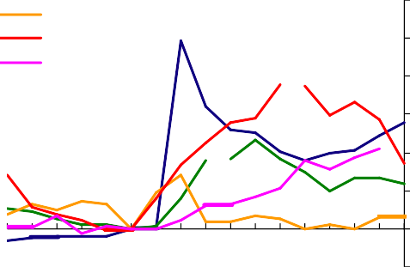**0=1978Q4**

**0=1990Q3**

**0=1999Q2**

**0=2004Q1**

**in real oil price 75**

**300 70**

**250 65**

**200 60**

**150 55**

**100 50**

**50 45**

**0 40**

**-50**

**Recruitment difficulties (rhs) 4**

**3**

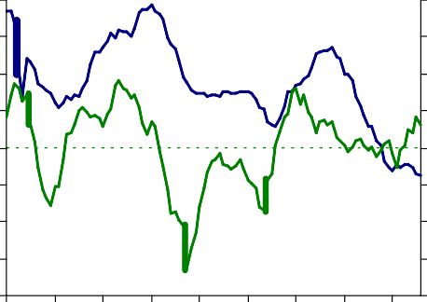

**Demand for staff (lhs)**

**2**

**1**

**0**

**-1**

**-2**

**-3**

**-6 -5 -4 -3 -2 -1 0 1 2 3 4 5 6 7 8 9 10**

**quarters**

Source: IMF

**35 -4**

**1998 1999 2000 2001 2002 2003 2004 2005 2006**

1. Recruitment difficulties are Bank Agents’ scores. A score

above zero implies employers are finding it more difficult than normal to recruit staff.

1. Demand for staff are REC data for permanent placements.
2. Dashed line is the long-run average of the REC data.

Source: Bank of England and Recruitment and Employment Confederation survey.

# Chart 7: Recruitment rate Chart 8: Employment intentions

**Thousands Thousands**

**Percentage balances**

**Services**

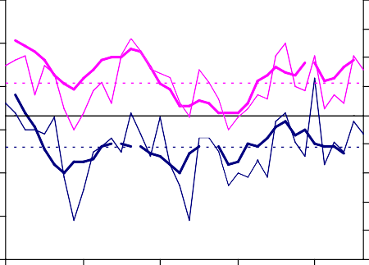

**Manufacturing**

**Score**

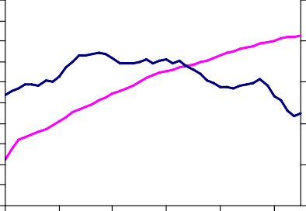**1800**

**1700**

**1600**

**1500**

**1400**

**1300**

**1200**

**1100**

**1000**

**900**

**800**

**1995 1997 1999 2001 2003 2005**

**29000**

**28000**

**27000**

**26000**

**25000**

**24000**

**40 4**

**3**

**30**

**2**

**20 1**

**0**

**10**

**-1**

**0 -2**

**-3**

**-10**

**-4**

**Stock (employed more than 3 months) (rhs) Recruitment (employed less than 3 months)**

**-20 -5**

**1997 1999 2001 2003 2005**

Source: Department of Work and Pensions.

1. Bold lines are Bank Agents’ scores for employers’ employment intentions over the most recent three months compared to a year earlier. These data have been lagged 1 quarter to make consistent with BCC data.
2. Narrow lines are BCC survey data on employment intentions over the next three months.
3. Dashed lines are long-run averages of the BCC data.

Source: Bank of England and British Chambers of Commerce.

# Chart 9: UK unemployment, employment and participation

**Per cent Per cent**

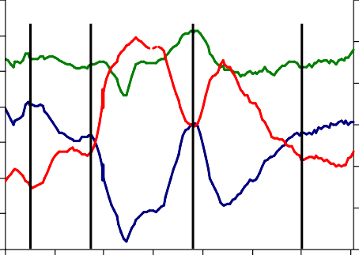

**Unemployment rate (lhs)**

**Activity rate (rhs)**

**Employment**

**rate (rhs)**

# Chart 10: International migration, to and from the UK

**sands**

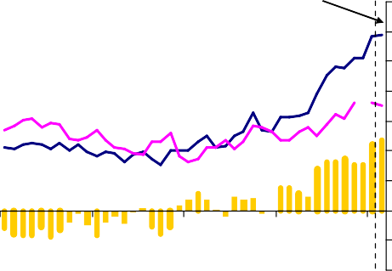

**Thou**

**2005 H1**

**Outflow**

**Inflow**

**Net inflow**

**14 66**

**12 64**

**10 62**

**8**

**60**

**6**

**4 58**

**2 56**

**0 54**

**700**

**600**

**500**

**400**

**300**

**200**

**100**

**0**

**-100**

**-200**

**1971 1976 1981 1986 1991 1996 2001 2006**

1. The vertical dashed lines mark the trough in the unemployment rate. They have been identified as 1973Q4, 1979Q2, 1990Q2 and 2005Q1.

Source: ONS.

**1964 1974 1984 1994 2004**

Source: IPS

# Chart 11: Pay Settlements Chart 12: AEI regular pay growth

**Twelve-month AEI-weighted mean,**

**per cent**

**4.0**

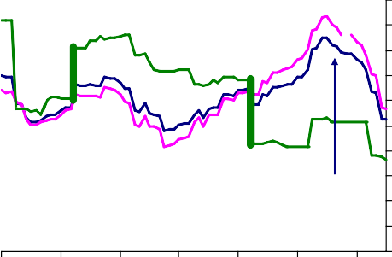

**Public**

**Private**

**Whole economy**

**3.8**

**3.6**

**3.4**

**3.2**

**3.0**

**2.8**

**2.6**

**2.4**

**2.2**

**2.0**

**2000 2001 2002 2003 2004 2005 2006**

1. Twelve-month AEI-weighted mean.

Source: Bank of England

**Per cent**

**6.0**

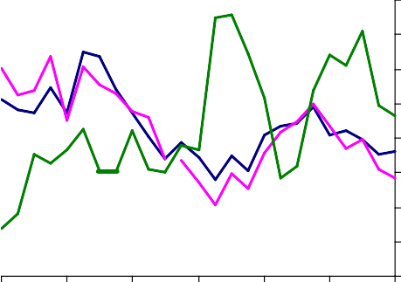

**Whole economy**

**Public**

**Private**

**5.5**

**5.0**

**4.5**

**4.0**

**3.5**

**3.0**

**2.5**

**2.0**

**2000 2001 2002 2003 2004 2005 2006**

1. AEI excluding bonus payments.

Source: ONS

# Chart 13: Average hourly wage Chart 14: CBI measure of capacity

**utilisation**

**Real (2005) wages**

**£ per hour**

**14**

Average since 1996

**Balance**

**60**



**'New' immigrants**

**UK born**

**All immigrants**

**50**

**12**

**10**

**8 40**

**6**

**4 30**

**2**

**0 20**

**1993 1995 1997 1999 2001 2003 2005**

1. Based on employees aged 16-64 who report their wage. Those earning above £100 per hour or below £1 an hour are removed to avoid the analysis being influenced by such extreme observations.
2. Real wages are based on 2005 prices as measured by the CPI.
3. ‘New’ immigrants are defined as those who entered the UK in the survey year or the (calendar) year before the survey was carried out.

Source: LFS and ONS.

**1996 1998 2000 2002 2004 2006**

Source: Confederation of British Industry

# Chart 15: BCC measure of capacity utilisation

**Chart 16: Capacity constraints – agent scores**

**e Services**

**Balanc**

**Averages since 1996**

**Services**

**Manufacturing**

**50**

**Manufacturing**

**45**

**40**

**35**

**30**

**25**

**20**

**Score**

**4**

**3**

**2**

**1**

**0**

**-1**

**-2**

**-3**

**1996 1998 2000 2002 2004 2006**

Source: British Chambers of Commerce

**1998 1999 2000 2001 2002 2003 2004 2005 2006**

1. A score above zero indicates greater than normal constraints on capacity.

Source: Bank of England

# Chart 17: Twelve-month ahead measures of households’ inflation expectations

**Balance Per cent**

# Chart 18: Current CPI inflation projection based on market interest rate expectations

**90**

**GfK NOP(a) (lhs)**

**Bank/ GfK NOP(b) (rhs)**

**YouGov/Citigroup(c) (rhs)**

**80**

**70**

**60**

**50**

**40**

**30**

**2003 2004 2005 2006**

**2.8**

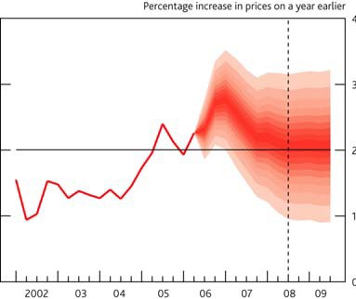**2.6**

**2.4**

**2.2**

**2.0**

**1.8**

**1.6**

1. Net balance expecting prices to increase. The question asks: ‘In comparison with the past twelve months, how do you expect consumer prices will develop in the next twelve months?’.
2. The survey takes place in February, May, August and November each year. The *median* responses are shown in the chart, calculated by assuming that responses are evenly distributed within bands. The observations for intervening months have been interpolated. The question asks: ‘How much would you expect prices in the shops generally to change the next twelve months?’ In February, the survey is conducted in two waves. For the February 2006 survey, the first wave was conducted in February and the second in March.
3. The question asks: ‘How do you expect consumer prices of goods and services will develop

the next twelve months?’. The series is monthly and started in November 2005.

Source: Bank of England, Citigroup, GfK NOP and YouGov.

Source: Bank of England, August 2006 *Inflation Report*